Assignment 10.6:

1.)Write a pig script to find the minimum temperature observed in a given weather station in a particular year.

NOTE – The dataset provided contains only one year.

Pig Script:

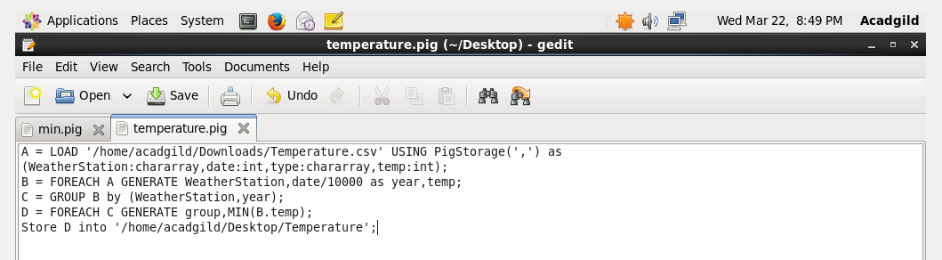

Output:

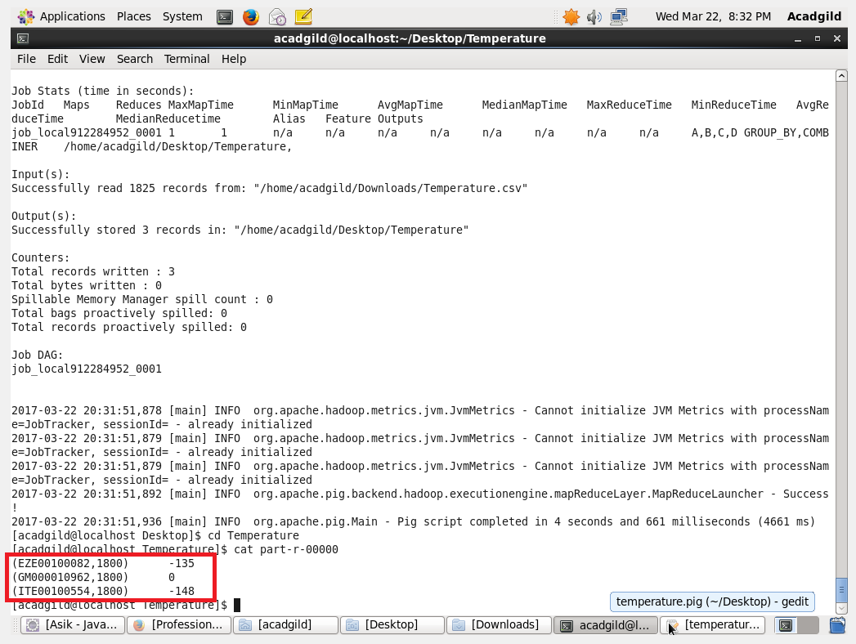

2. Write a pig script to find the maximum temperature observed in a given weather station in a particular year.

Pig Script:

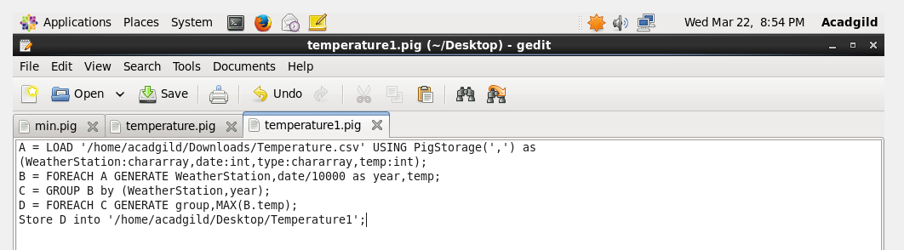

Output:

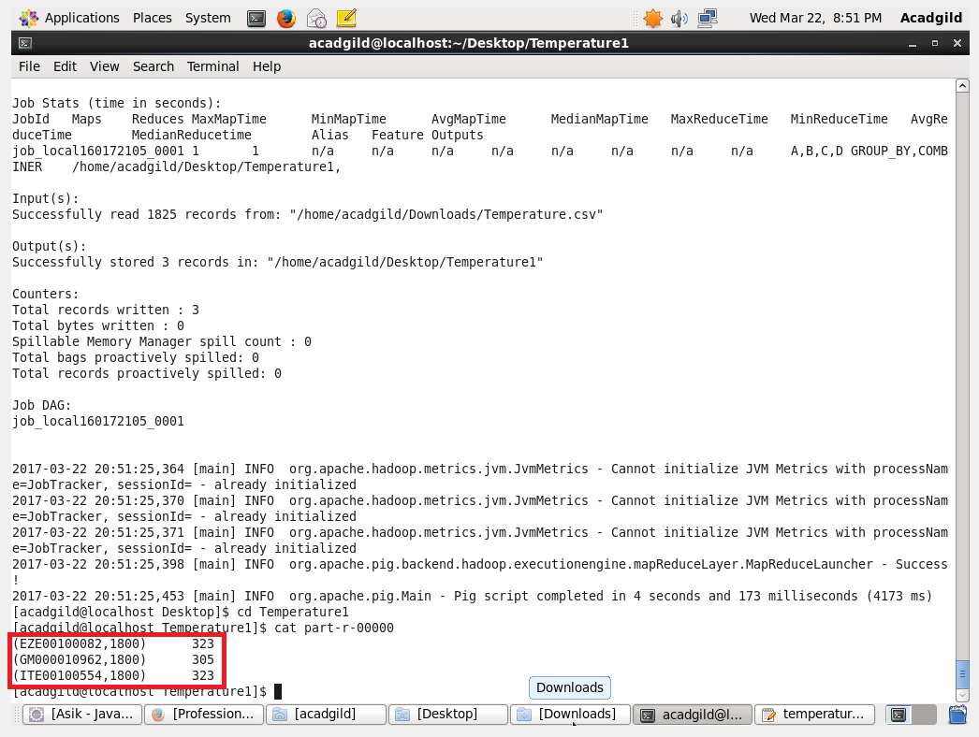

3. Write a pig script to find the number of readings given by each weather station according to the dataset.

Pig Script:

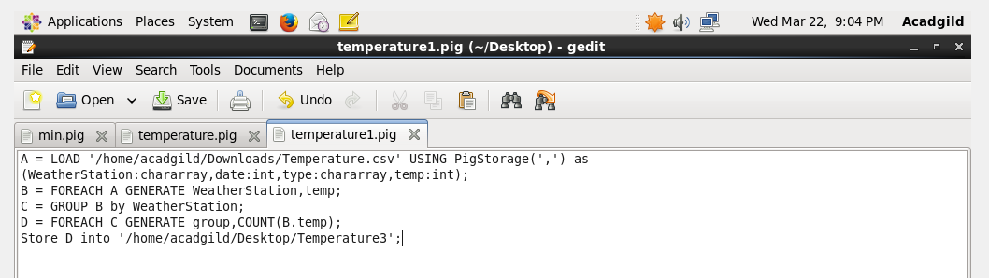

Output:

